Experiment No:01

Experiment Name: How To Set Up Linux Ubuntu.(17.10)
Aim and Object:
Linux is an operating system just like Windows; Mac OS X developed by Linus Torvalds in 1991. Operating system is the interface between the softwere and hardwere. It provides services for the applications and manages computer hardware. Initially, Linux was just an operating system but now it became the platform to run desktops, embedded systems, and servers. It was developed as an alternative for Minix (UNIX clone developed by Andrew S. Tanenbaum). Linux has many variations and distributions because of its modular design. A kernel is at the base or core of the Linux system. It schedules applications or processes, manages basic peripheral devices, handles network access and oversees file system services. Linux provides many advantages over other operating systems and that is why it is used almost in every field nowadays, from smartphones to supercomputers, cars to home appliances and many more.
We use linux operating system because:
- Linux is Free an Open Source.
- Linux can run low Hardware machines too.
- Well supported.
- Lots of Flavors.
- Good security.
Experiment Setup:

Step 1: Prepare Windows Machine for Dual-Boot
1. The first thing you need to take care is to create a free space on the computer hard disk in case the system is installed on a single partition.
Login to your Windows machine with an administrative account and right click on the Start Menu -> Command Prompt (Admin) in order to enter Windows Command Line.

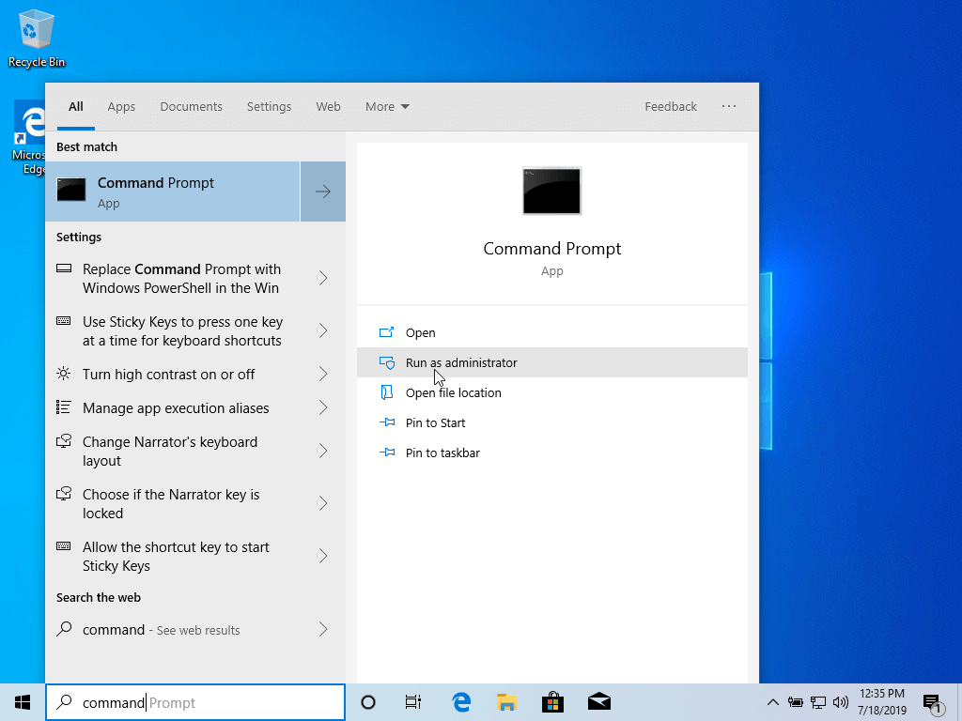
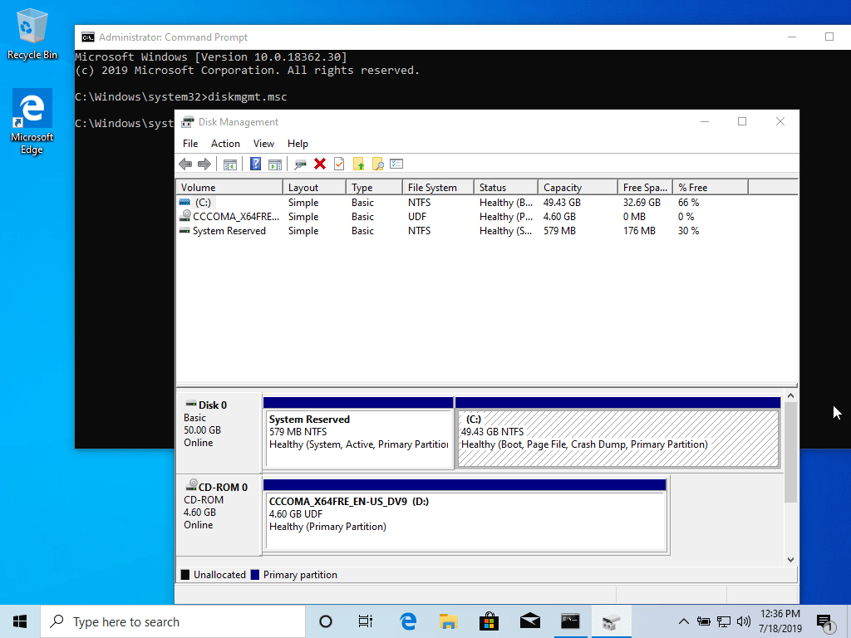
2. Once in CLI, type diskmgmt.msc on prompt and the Disk Management utility should open. From here, right click on C: partition and select Shrink Volume in order to resize the partition.
3. On Shrink C: enter a value on space to shrink in MB (use at least 20000 MB depending on the C: partition size) and hit Shrink to start partition resize as illustrated below (the value of space shrink from below image is lower and only used for demonstration purposes).Once the space has been resized you will see a new unallocated space on the hard drive. Leave it as default and reboot the computer in order to proceed with Ubuntu installation.

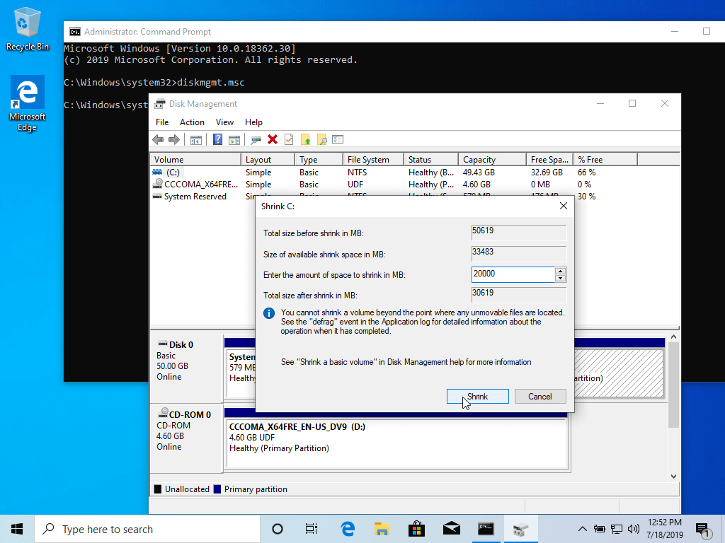
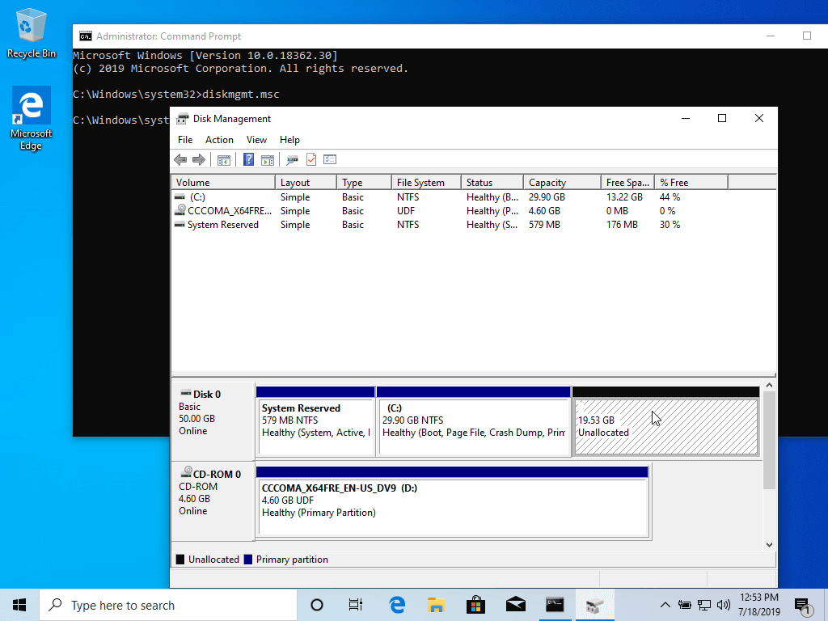

Step 2: Install Ubuntu with Windows Dual-Boot
4. For the purpose of this article, We will be installing Ubuntu 19.04 alongside with Windows dual boot (you can use any Ubuntu release fro installation). Go the download link from the topic description and grab Ubuntu Desktop 19.04 ISO image.
Burn the image to a DVD or create a bootable USB stick using a utility such as Universal USB Installer (BIOS compatible) or Rufus (UEFI compatible).
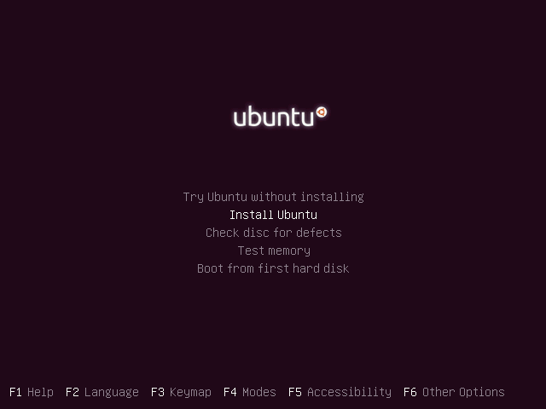
5. After the boot media finishes loading into RAM you will end-up with a completely functional Ubuntu system running in live-mode.
On the Launcher hit on the second icon from top, Install Ubuntu 19.04 LTS, and the installer utility will start. Choose the language you wish to perform the installation and click on Continue button to proceed further.
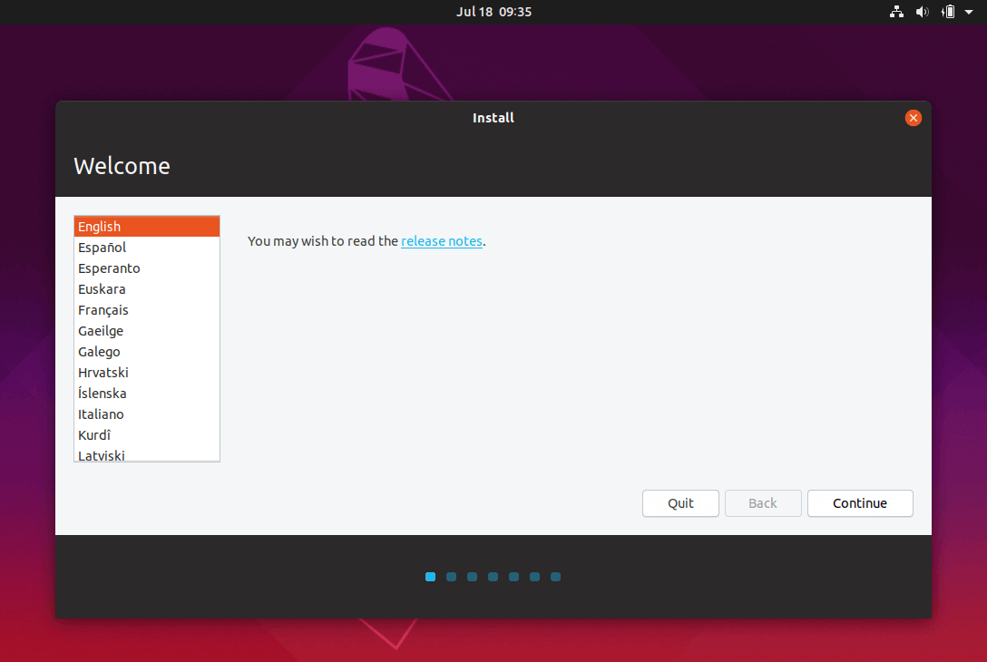
6. Next, choose the first option “Normal Installation” and hit on Continue button again.

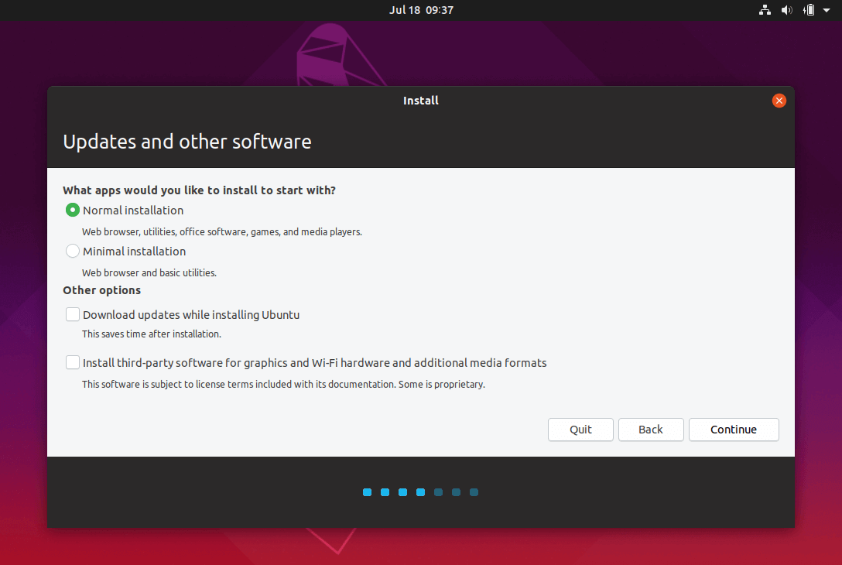
7. Now it’s time to select an Installation Type. You can choose to Install Ubuntu alongside Windows Boot Manager, option that will automatically take care of all the partition steps.
Use this option if you don’t require personalized partition scheme. In case you want a custom partition layout, check the Something else option and hit on Continue button to proceed further.
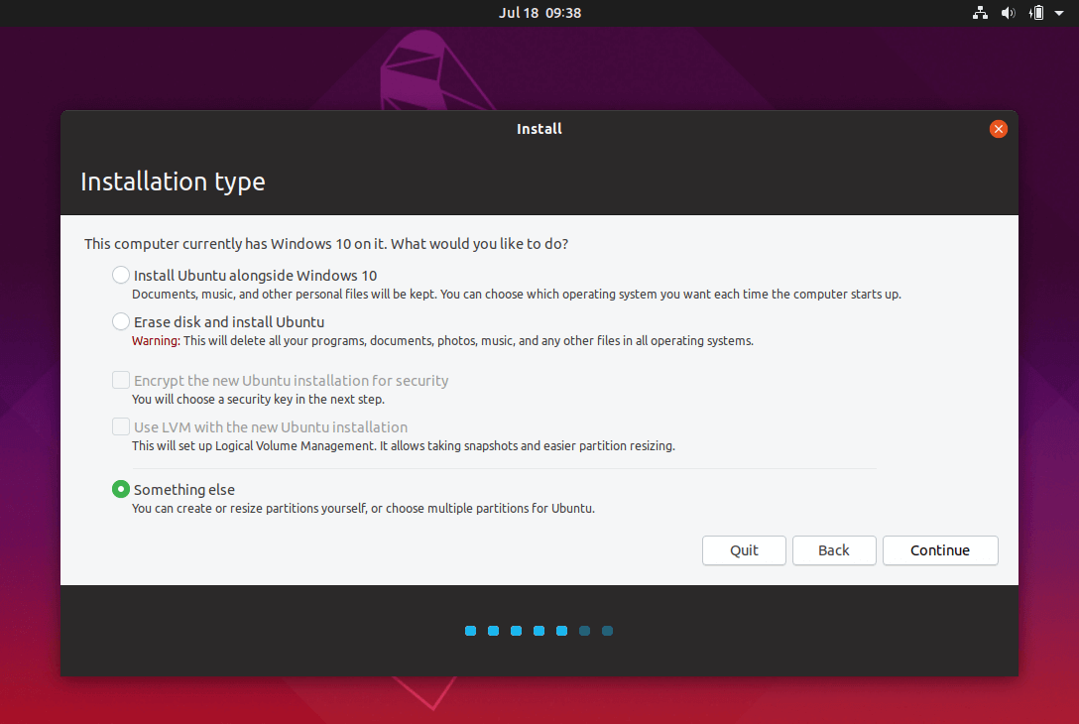
8. On this step we’ll create our custom partition layout for Ubuntu. On this guide will recommend that you create two partitions, one for root and the other for home accounts data and no partition for swap (use a swap partition only if you have limited RAM resources or you use a fast SSD).
To create the first partition, the root partition, select the free space (the shrink space from Windows created earlier) and hit on the + icon below. On partition settings use the following configurations and hit OK to apply changes:
- Size = at least 20000 MB
- Type for the new partition = Primary
- Location for the new partition = Beginning
- Use as = EXT4 journaling file system
- Mount point = /
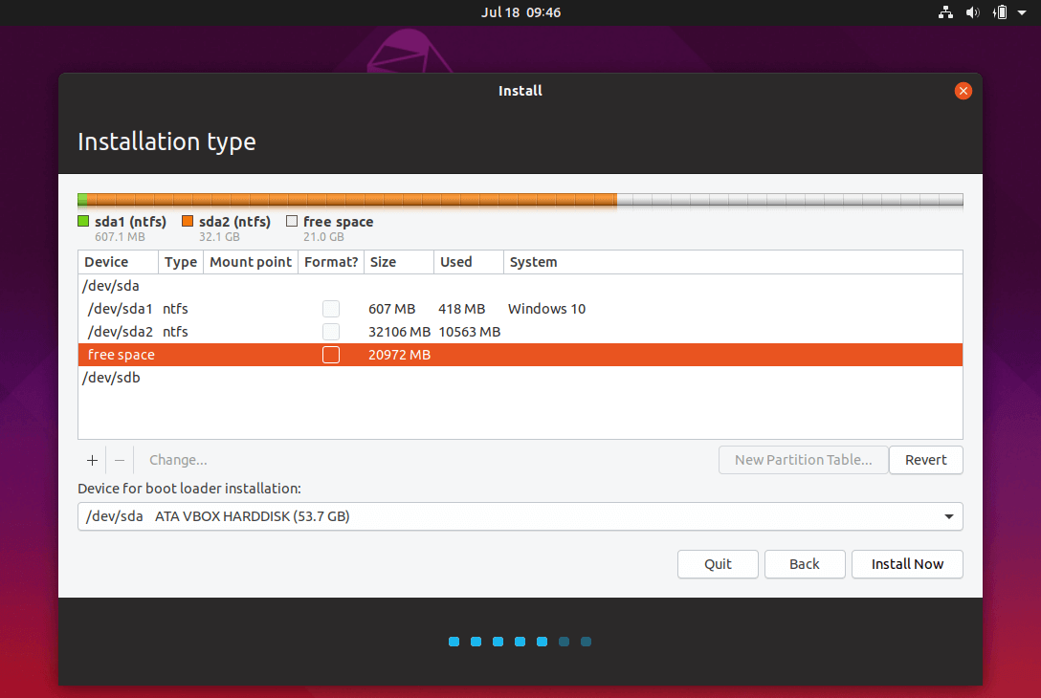
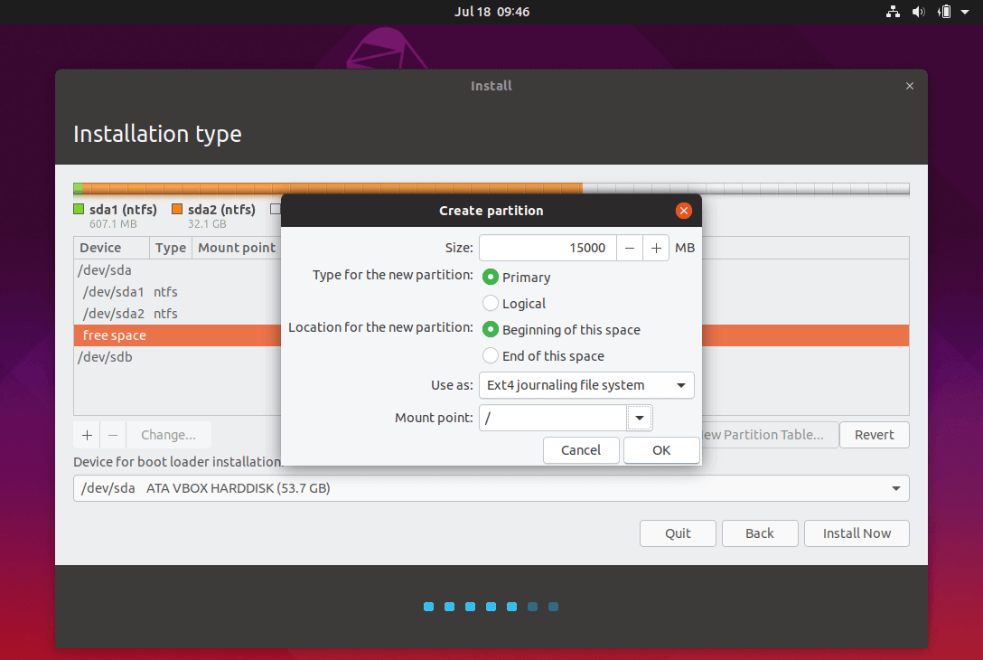
Create the home partition using the same steps as above. Use all the available free space left for home partition size. The partition settings should look like this:
- Size = all remaining free space
- Type for the new partition = Primary
- Location for the new partition = Beginning
- Use as = EXT4 journaling file system
- Mount point = /home

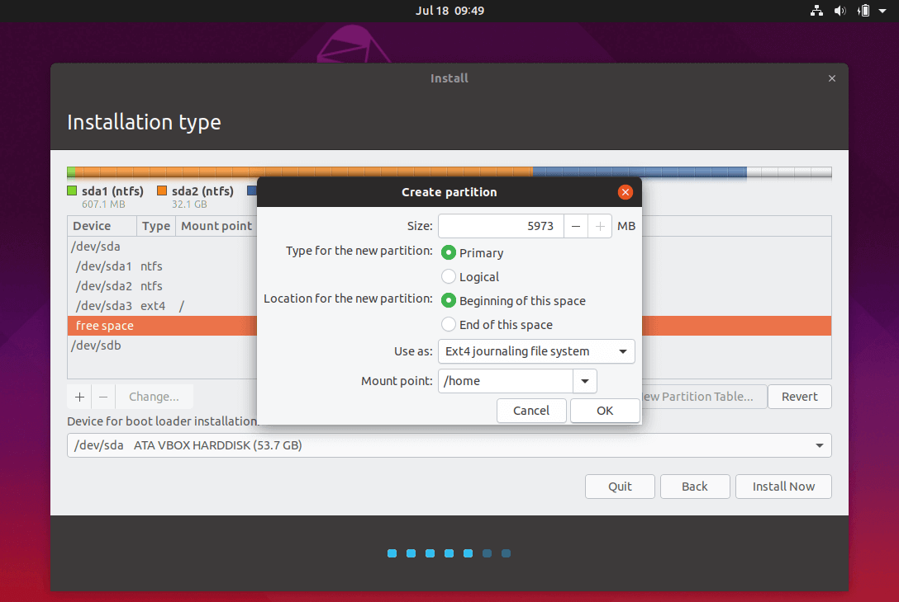
9. When finished, hit the Install Now button in order to apply changes to disk and start the installation process.
A pop-up window should appear to inform you about swap space. Ignore the alert by pressing on Continue button.
Next a new pop-up window will ask you if you agree with committing changes to disk. Hit Continue to write changes to disk and the installation process will now start.
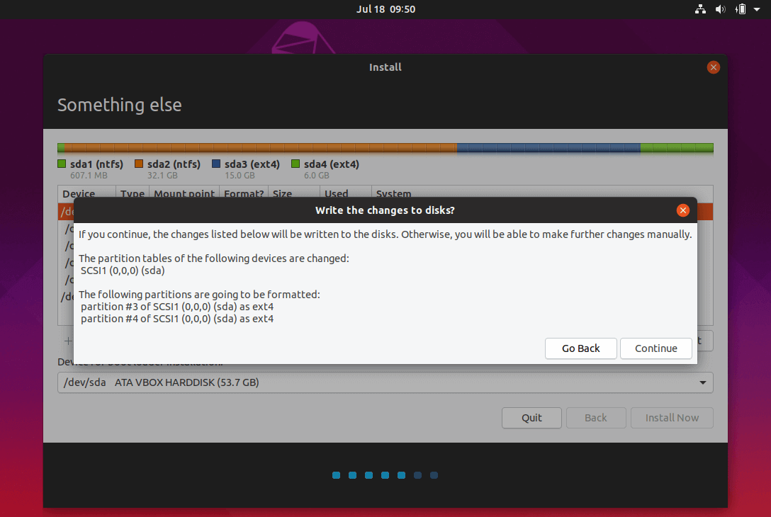
10. On the next screen adjust your machine physical location by selecting a city nearby from the map. When done hit Continue to move ahead.
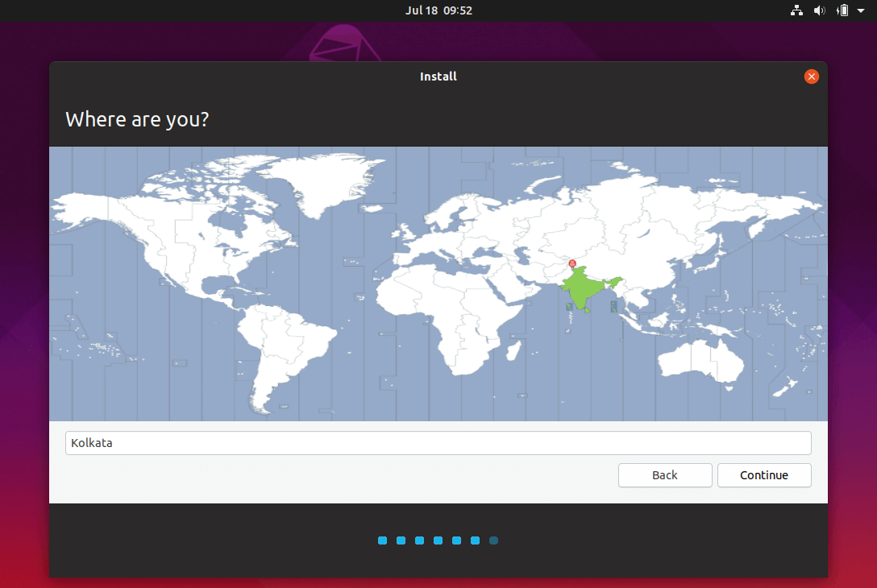
11. Pick up a username and password for your administrative sudo account, enter a descriptive name for your computer and hit Continue to finalize the installation.
This are all the settings required for customizing Ubuntu installation. From here on the installation process will run automatically until it reaches the end.
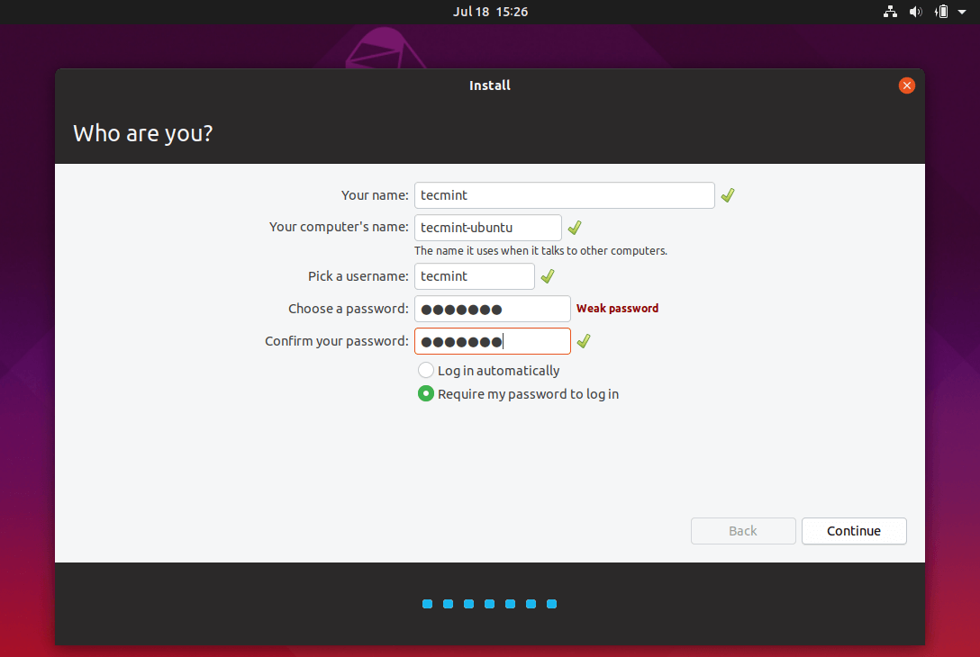
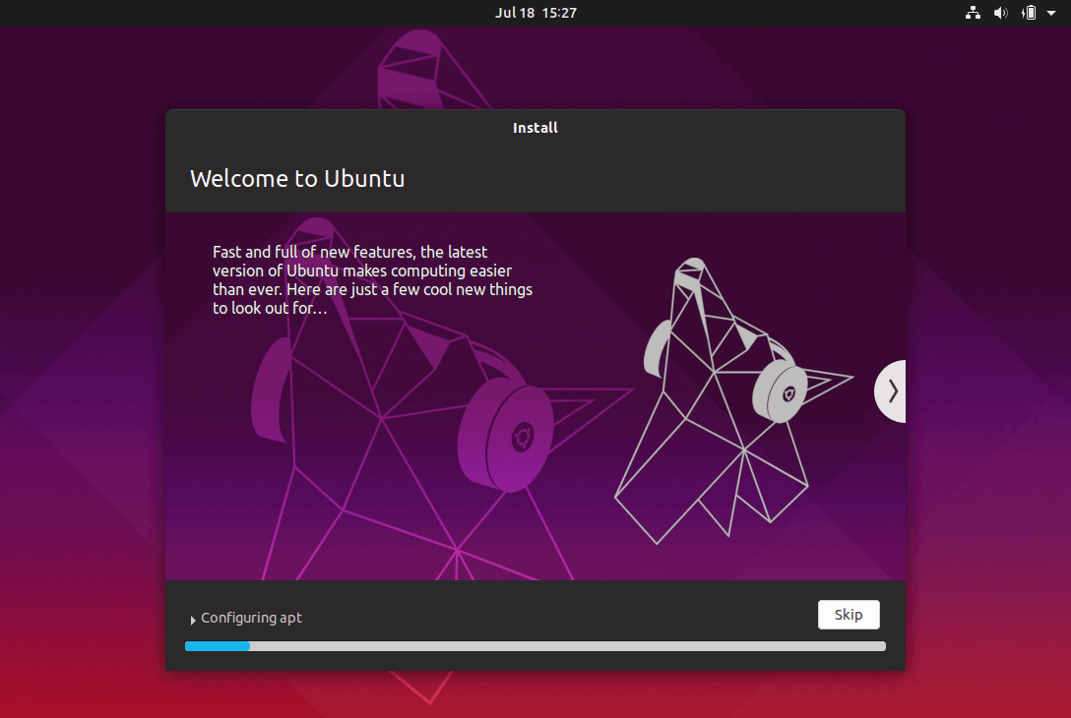
12. After the installation process reaches its end hit on Restart Now button in order to complete the installation.
The machine will reboot into the Grub menu, where for ten seconds, you will be presented to choose what OS you wish to use further: Ubuntu 19.04 or Microsoft Windows.
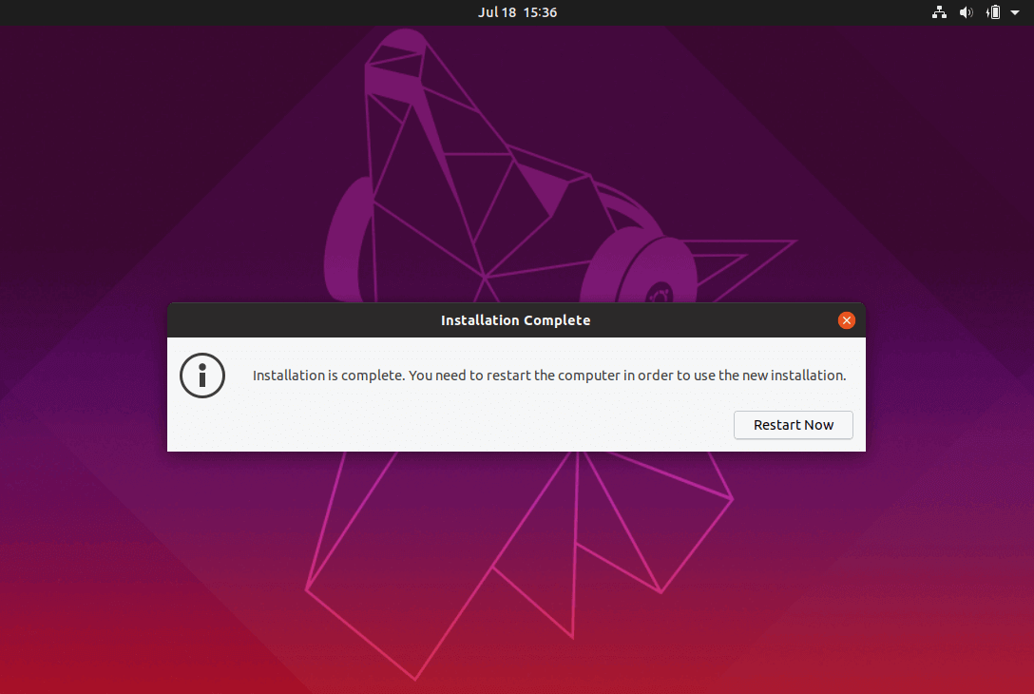
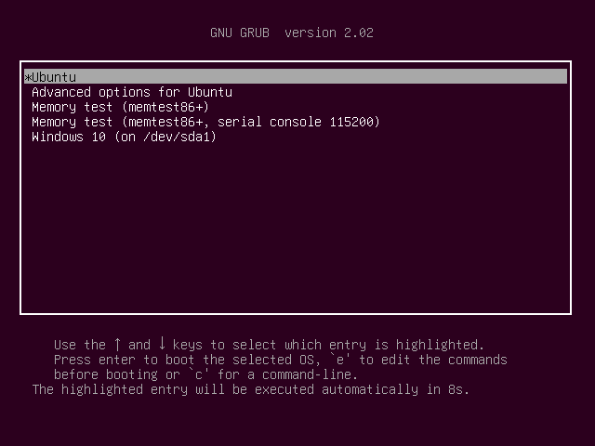
13. After Ubuntu finishes loading, login with the credentials created during the installation process and enjoy it. Ubuntu provides NTFS file system support automatically so you can access the files from Windows partitions just by clicking on the Windows volume.
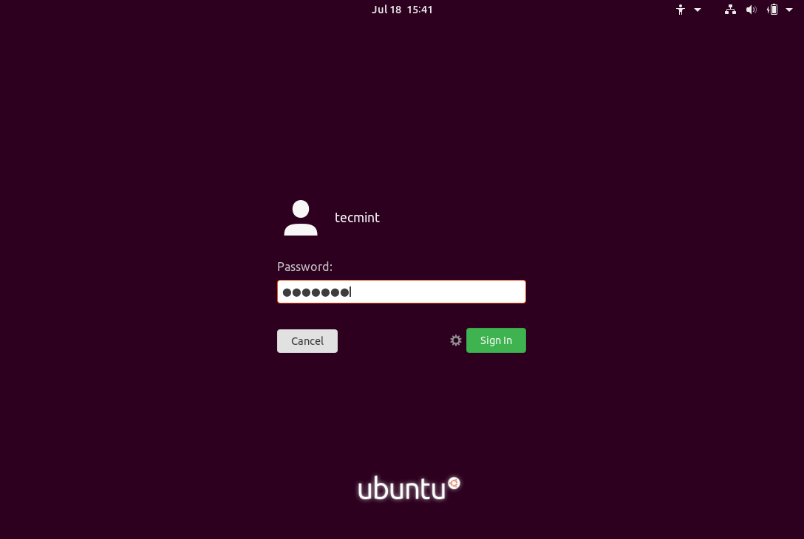
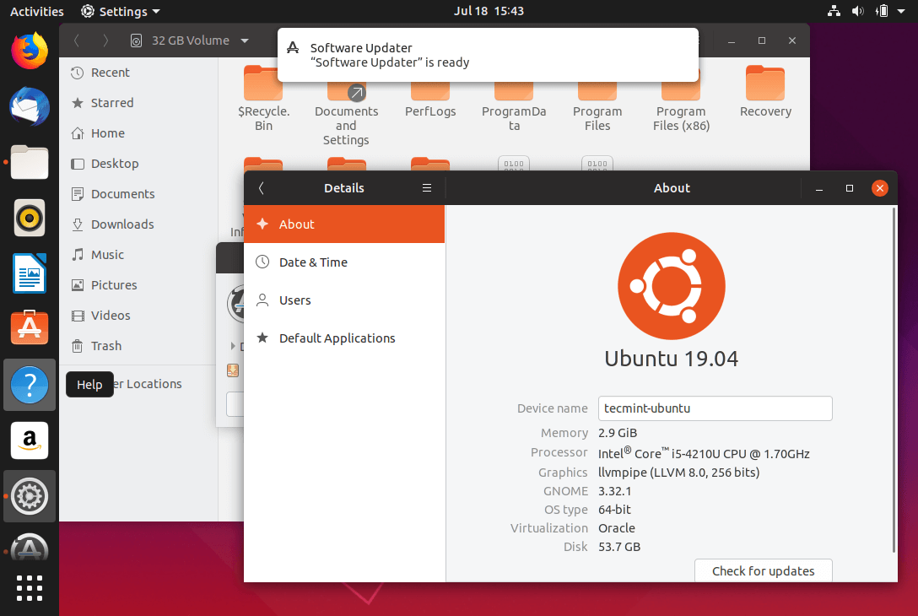
That’s it! In case you need to switch back to Windows, just reboot the computer and select Windows from the Grub menu.

